**Time Distributor v1 (Pre-GUI version)**

Git Repo: <https://github.com/jm55DLSU/TimeDistributor>

Future version is to be updated with a proper interface.

1. Create a .csv file containing the names of the people (Required)
   1. Open the existing spreadsheet file of names
   2. Copy the names on a new spreadsheet file
      1. Copy existing namesGraphical user interface, application, table, Excel

         Description automatically generated
      2. Paste to new Excel windowGraphical user interface, application, table, Excel

         Description automatically generated
   3. Save the new spreadsheet as ‘.csv’  
      Graphical user interface, application

      Description automatically generated
2. Using the program
   1. Open the program  
      Graphical user interface, application

      Description automatically generated
   2. Select the recently saved .csv file containing the names.Graphical user interface, application

      Description automatically generated
   3. Enter the total time in ‘hh:mm:ss’ format. Place a zero in each non-filled index (e.g., 01:01:01 instead of 1:1:1) like the one on the second image.Graphical user interface, application

      Description automatically generated

* 1. Do the same for the duration.

* 1. A save file pop-up will show, please proceed to the desired path and enter the desired file name of the output file and click Save. Graphical user interface, application, Word

     Description automatically generated

1. Open the newly saved file and it is recommended for you to save it as a ‘.xlsx’ (Excel) file.  
   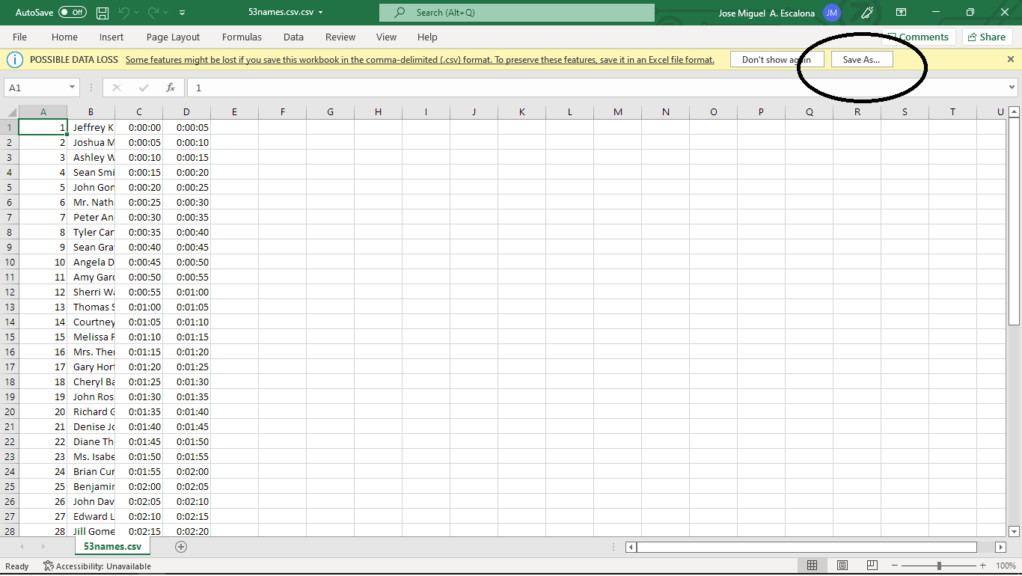  
   Graphical user interface, application

   Description automatically generated